Vehicle-to-Vehicle (V2V) communication protocol and collision detection system
🚗 Transmitter Node Connections
- Ultrasonic Sensor (HC-SR04)
  - TRIG → GPIO 5 (ESP32)
  - ECHO → GPIO 18 (ESP32)
- GPS Module
  - TX → GPIO 16 (ESP32, RX pin of HardwareSerial1)
  - RX → GPIO 17 (ESP32, TX pin of HardwareSerial1)
  - Baud rate: 9600
- ESP32 Board
  - Configured in WiFi Station Mode (WIFI_STA)
  - Sends data via ESP-NOW protocol
- Power Supply
  - 5V/3.3V regulated supply for ESP32 and sensors
🚙 Receiver Node Connections
- OLED Display (SSD1306, I2C)
  - SDA → GPIO 21 (ESP32 default I2C SDA)
  - SCL → GPIO 22 (ESP32 default I2C SCL)
  - Address: 0x3C
- Buzzer
  - Positive terminal → GPIO 4 (ESP32, OUTPUT)
  - Negative terminal → GND
- ESP32 Board
  - Configured in WiFi Station Mode (WIFI_STA)
  - Receives data via ESP-NOW callback function
- Power Supply
  - 5V/3.3V regulated supply for ESP32, OLED, and buzzer
🔄 Data Flow Connections
- Transmitter ESP32
  - Reads distance from ultrasonic sensor
  - Reads GPS data (lat, lon, speed)
  - Packages into Message struct
  - Sends via ESP-NOW to receiver MAC address
- Receiver ESP32
  - Receives packet via callback
  - Decodes struct (distance, speed, lat, lon)
  - Displays values on OLED
  - Activates buzzer if:
    - Distance < 20 cm OR Speed > 60 km/h
⚡ Summary of Key Wiring
- Transmitter: Ultrasonic (GPIO 5, 18), GPS (GPIO 16, 17)
- Receiver: OLED (GPIO 21, 22), Buzzer (GPIO 4)
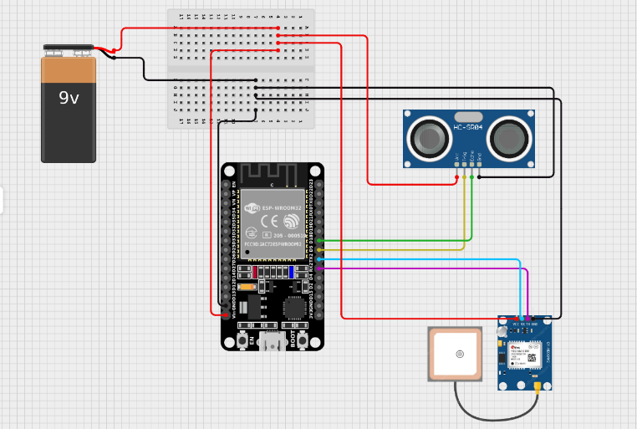

TRANSMISSION NODE

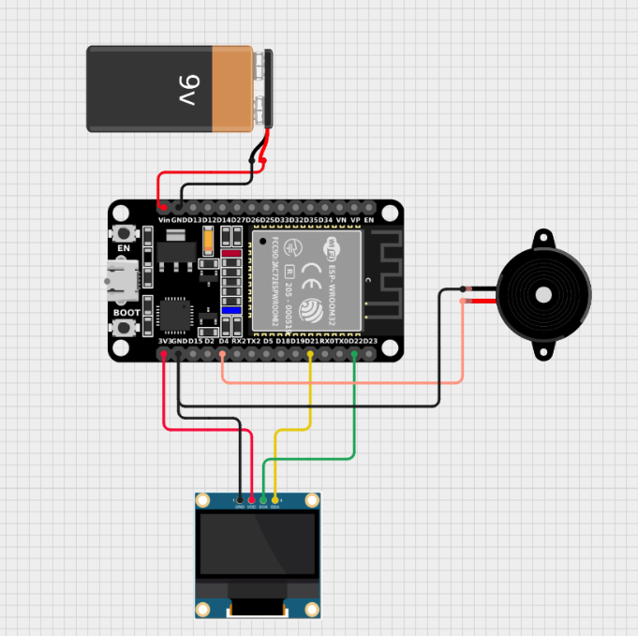

RECEIVER NODE

